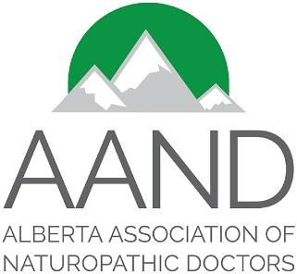
P.O. Box 78076 RPO Heritage
Calgary, AB T2H 2Y1
www.AlbertaNDs.ca
executivedirector@albertands.org

Dear Members:

Pursuant to the bylaws of the organization, we provide to you today a list of candidates with their biographical information in regard to the upcoming AGM to be held Friday June 3, 2022. Information on the AGM can be found on our website, along with a proxy form and procedures should you be unable to attend in person and still wish to vote.

Hillary Dinning, ND

Dr. Hillary Dinning is a member of the Alberta Association of Naturopathic Doctors and has served as president for the past year. Hillary is a naturopath in Alberta and the focus of her practice is in children's medicine, specifically ADHD and autism, fertility and chronic conditions. She graduated in 2014 from the Canadian College of Naturopathic Medicine (CCNM) in Toronto, is a standing member of the Canadian Association of Naturopathic Doctors (CAND), registered with the College of Naturopathic Doctors of Alberta (CNDA) as well as a member of the Pediatric Association of Naturopathic Physicians (PedANP).

Hillary has three crazy children that keep her humble, loves spending time with her husband Dave and has a passion for running and skiing. She loves learning new information - about friends, family and strangers or the next webinar that catches her eye in children's health. Her happy place is in front of a plate of nachos followed by a gluten free brownie from her favourite local shop. She may call it heaven :)

Lorraine McCarthy, ND

Dr. Lorraine McCarthy is a naturopathic doctor in Edmonton, Alberta and has served two years as a board member of the Alberta Association of Naturopathic Doctors. Lorraine shares that the past two years on the board have given her insight into the issues of our profession in Alberta and the role of the AAND in addressing them. She feels that these experiences prepare her to continue moving forward the work of the organization.

More recently, Lorraine has been focused on furthering the marketing goals of the AAND and is keen to extend her work in this area. Increasing the awareness of the AAND and the naturopathic profession in the general population are important priorities to which she feels she can successfully add value.

Lorraine is excited for the opportunity to continue her contribution to the membership and profession for another term.

The Alberta Association of Naturopathic Doctors

